The Box Within

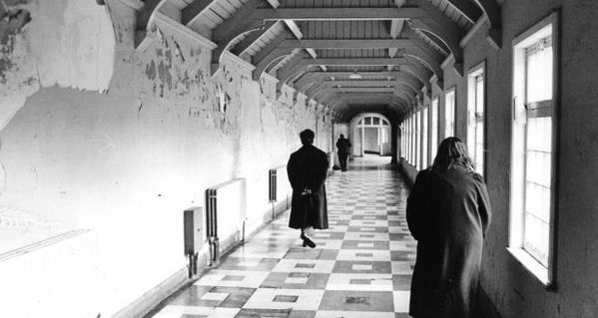



Age Rating:



Target Audience: Middle class, Male, Early twenties,

Story and Gameplay

**Act 1**

Walter Davey is being brought into Hamshire asylum, he is introduced to Dr. Wenton who is charged with analysis and curing Davey. Dr. Wenton tells Davey he is an ill man and that he will be able to help him, he gives him pills that will help him manage his schizophrenia. Davey feels he is saved until he interacts with other patients, the lunatics, where he finds out that no one has left the asylum and that everyone is on the pills. Feeling like he is able to face his demons, Davey begins to explore the asylum to find clues to his past and how to deal with his problems.

**Act 2**

Considered a good patient, Davey is allowed to access the facilities on the first floor. While exploring the asylum, Davey meets one of the many doctors, Dr. Edwards, a man who has worked in the asylum for many years and had grown distaste towards the patients. Davey talks with Edwards who in passing taunts him about the loss of his mother which brings back memories of a past Davey has forgotten. Waking up from the flashbacks of his past, Davey begins to hear a voice in his head, the voice of his mother, Katherine, who begins to talk to him. While speaking to his mother, Dr. Wenton walks in, revealing that he was observing Davey speak to himself and that he is in need of more treatment to help him deal with his problems. Days after his treatment, he is released again but under strict watch. Remembering part of the past and having the voice of his mother guide him, Davey continues his exploration of the asylum and more of his past, knowing that there is much more to uncover. With the first floor still open, Davey has access to level two and level three. In level two, Davey can find the library, canteen and the outside yard. In level three, there are doctors offices, most of which are locked, and stairs to the upper floors. Exploring the facilities will reward the player with new items that will both aid in his progression of finding out his past memories and also letting him gain access to the offices. Talking to patients and doctors, might reward you with hints and open up other options for gaining access to areas and rooms. How Davey’s interaction changes based upon the level of insanity he is at, determined by time spent without pills and the events that happen. Order of the memories found doesn’t matter but every new memory found will drive him further into madness. Voices that are gotten will guide you, helping you with remembering the past but can also hurt Davey, driving him insane, taunting him, causing a bad reputation amongst the doctors and patients.

**Act 3**

Once level two and three are explored, with the various memories being discovered, Davey will now gain access to the fourth level, the upstairs of the asylum. Offices of important doctors and rooms with important information and documents are available to explore but most be done carefully as this is a highly restricted area and if you are caught searching around, will be brought back and treated again. Important documents can be found in Dr.Wentons office and the storage room, where many past items and information on Davey can be found. The information found on the fourth level will further interactions with the voices, which can show him visions, it is up to Davey to realise what is real and what is fake

**GITHUB LINK:** https://keithbutler-wit.github.io/GameDesign-Assignment02/

Game Flow

Each individual player plays the game their knowledge on how to handle the certain NPCs grows. They learn what dialog choices to make to lead to their desired results. After their first encounter with npc the player should have a slight understanding on that npcs personality and what not to say.

As the player progresses throughout **The Box Within** they’ll collect clues to aid in their escape.

Characters and Controls

The player will be controlling a man by the name of Walter Davey. Who was recently admitted to a mental asylum in the hopes of curing his illness.

The way the player interacts with Walter Davey is through dialog and the player selecting one of a small few movement directions.

**Protagonist: Walter Davey**

**Motivations:** A powerful drive to uncover the truth

**Personality:** Curious, Mentally ill (Schizophrenia)

**Appearance:** undone Straitjacket, messy hair

**Goals:** Make it out of the asylum and escape from the grips of Dr. Warden Sir.

**Wants:** Pills to hold back the voices

**Needs:** Confront his past traumas

**Background:** Losing both of his parents early, Walter has a rough life with many of his mental problems stemming from his inability to deal with his past and causing his schizophrenia to get worse. Eventually he gets into a position where he has his dream job as a mechanic and a family he loves. However he loses his family to a disease, leaving only him and unable to cope with the loss, his previous problems rise up again, worse than before leading him to be put into a mental asylum.

**Antagonist: Doctor Edwards**

**Motivations:** Years of working with patients have made him grow to hate them, going out of his way to make patients look worse than they actually are. Believes his methods of dealing with patients are superior to any other doctor and that there are no cure or help for the patients, that they will remain ill for the rest of their life.

**Personality:** Cruel, Malicious, Manipulative

**Appearance:** 1940’s hospital attire, face mask (Worn at all times), clean combed hair.

**Goals:** To demonstrate that the patients are all, except a few, untreatable and must be kept in their rooms under strict.

**Wants:** To see the patients suffer due to his own unhappiness and that they are seen as prisoners, not patients.

**Needs:** To prevent any patients from escaping.

**Tritagonist: Katherine Davey**

Is the mother of Walter Davey and the first voice in his head. She guides him through a lot of his memories and helps him escape.

**Motivations:** She wants to help her son escape the asylum and make sure he is healthy but these two things may conflict throughout the game. She is the voice of reason in Daveys head, sometimes more sane that Davey is himself. However she changes her intent based on Davey's situation, convincing him to take the pills if she feels he is losing it or helps him uncover his past if she feels he is able to handle it but oftentimes will take his health as priority over his escape.

**Personality:** Caring, treats Davey as still the little boy that he was when she passed.

**Appearance:** Davey can’t remember his mothers face, only remembering him as a voice in his head.

**Goals:** To guide her son through tough spots

**Wants:** Her son to be free

**Needs:** Nothing she’s a fucking voice in his head for fuck sake

**Important NPC: Doctor Wenton**

Dr.Wenton is a long time worker in the asylum and is assigned to treat Walter Davey.

**Motivations:** Passionate about her work as a doctor, attempts to help the patients she works with as well as she could, documenting their behaviour as much as she can while keeping history of the patients with her. Being a doctor for a long time, she has learned ways of helping minimise insanity among patients, ones that other doctors might have seen as untreatable and incurable.

**Personality:** Generally an open minded person and is very approachable especially for patients who might seek help from her. When it comes to treating patients she takes it very seriously, making sure she is able to get all the important information about the patient from them. She doesn’t give up easily, making sure patients are medicated when needed but can give up or lose hope if the patient shows no sign of improvement.

**Appearance:** Well kept, professional in appearance, later 40s.

**Goals:** Help all patients to the best of her ability, attempts to help get them out of the asylum.

**Wants:** To see the patients suffer due to his own unhappiness

**Needs:** To prevent any patients from escaping

Main Gameplay concepts and platform specific features:

**The Box Within** is only and will only be playable in the browser. There’s no plan to release this game on other platforms.

The main concept of the game is to choose different dialogues to achieve an ending. However players have no way of knowing what ending they will achieve so they must choose wisely.

As the player progresses an option to take a pill or not take a pill will occur. This will be optional and will have an effect on the story.

At certain points in the story the player will need to avoid the doctors and sneak around the asylum undetected. This is achieved by choosing a route that they think will be clear of doctors and detection means being brought back to the main characters room.

The main benefit of being a browser only game is the controls are a simple click the option you want and it can be restarted quickly and easily.

Game World

The story of **The Box Within** takes place in Hamshire asylum.

This place is run by two notable doctors with opposing beliefs on how patients should be treated.

This asylum has two floors. The ground floor is where the patients living quarters are and various essential rooms such as a canteen are located.

The first floor is where the more off limits areas are for the patients at least. This particualy area of the game will ensure a feeling of terror and tence.

**Game Mechanics:**

**The Box Within** is a text based interactive story game. The game play spans from talking to the NPCs to find clues from the dialog to find out about life in the asylum and possible methods of escape.

**Level Flow Diagram:**

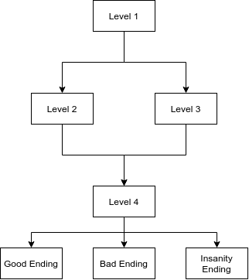

Cutscenes, Bonus materials and comps

The Box Within is a text based game where all the story will be given to the player throughout their gameplay in the form of snippets of conversations with fellow patients. No cutscenes are present in **The Box Within.**